# AI for Liver Disease Outcome Prediction

Table of Contents

Task A 3

a. Introduction to the Concept of Deep Learning (L01) - AI for Liver Disease Prediction 3

Task B 4

b. Literature Review of Similar Applications (L01, L03) 4

1. Predicting Liver Disease Using Random Forests 4

2. Deep Learning for Survival Prediction 4

3. Explainable AI: XGBoost + SHAP 5

4. A Real-World Kaggle Solution: Ensemble Modeling for Wilson’s Disease 5

Conclusion 5

Task C 6

c. Exploratory Data Analysis (EDA) (LO2) 6

1. Understanding the Dataset 6

2. Visual Insights: Telling Stories Through Charts 6

3. Feature Engineering Ideas That Emerged 7

Conclusion 8

Task D 9

d. System Architecture and Machine Learning Technique (LO2) 9

1. System Architecture Overview 9

2.How Our Application Stands Out 10

3.Machine Learning Technique: Why Random Forest? 10

Task E 11

e. Full Model Evaluation, Implementation Details & Practical Demonstration (LO2) 11

Implementation Details: End-to-End System 11

Project Structure Overview 11

Backend - service.py (Flask API) 12

Frontend - React.js 15

Function Flow and Library Usage 16

Final Thoughts 17

Task F 19

f. Conclusion of the Final Model and the Success of Using Deep Learning Techniques in the Healthcare Domain 19

# Task A

## a. Introduction to the Concept of Deep Learning (L01) - AI for Liver Disease Prediction

In today’s world, healthcare systems are increasingly relying on intelligent technologies to improve diagnosis, treatment, and patient outcomes. Among these, artificial intelligence (AI) has become a transformative force, especially in analyzing complex medical data and supporting clinical decisions. One of the most powerful subsets of AI is deep learning, a technique inspired by the structure and function of the human brain, capable of uncovering hidden patterns in vast amounts of data.

Deep learning falls under the broader umbrella of machine learning, where systems learn from data rather than being manually programmed. Unlike traditional algorithms that require predefined rules, deep learning algorithms can automatically discover intricate relationships within data, making them particularly effective for tasks like predicting patient survival, detecting disease progression, and interpreting diagnostic images.

In the context of liver disease, timely and accurate prediction of patient outcomes can mean the difference between life and death. Liver diseases are often complex and influenced by many interacting factors such as blood parameters, age, gender, and lifestyle. Traditional medical scoring systems may fail to capture these nuances. This is where deep learning models excel, they can process a wide range of inputs and make predictions with remarkable accuracy.

This project, titled “AI for Liver Disease Outcome Prediction”, leverages deep learning to analyze patient data and predict whether a patient is likely to survive or succumb to liver disease. By training a model on real-world clinical datasets, the aim is to assist doctors in making faster, more informed decisions, particularly in resource-constrained or high-pressure environments.

With the rise of digital health records and biomedical data, deep learning offers a unique opportunity to personalize medicine and support early intervention strategies. From a technical perspective, the models used in this project consist of multiple neural layers, each learning features such as protein levels, bilirubin, platelet counts, and more, ultimately generating a risk prediction. These models are then integrated into a user-friendly software application to simulate how they might function in a clinical environment.

In essence, deep learning is not just a technological tool, it is a potential lifesaver. By applying it to real-world problems like liver disease outcome prediction, we move one step closer to intelligent systems that augment medical professionals, reduce human error, and save lives.

# Task B

## b. Literature Review of Similar Applications (L01, L03)

Artificial Intelligence (AI) is increasingly transforming the healthcare landscape, and liver disease prediction is one of the areas benefiting from this shift. With liver diseases being a silent killer that often go undetected until it's too late, researchers have turned to machine learning (ML) and deep learning (DL) techniques to help forecast outcomes and provide early intervention opportunities.

This section explores how similar AI models have been used in the past to predict liver-related conditions. By comparing their approaches, strengths, and limitations, we can better understand how our project fits into the broader research ecosystem and how we aim to improve on previous efforts.

### 1. Predicting Liver Disease Using Random Forests

One of the most commonly referenced datasets for liver disease research is the Indian Liver Patient Dataset (ILPD). In one study, researchers used a Random Forest classifier to predict whether someone had liver disease or not. The model performed reasonably well, reaching around 72% accuracy. What made Random Forests effective here was their ability to handle missing data and reduce overfitting by averaging predictions from many decision trees.

**However, the study focused on detecting the presence of disease, not predicting outcomes like survival or death, which limits its usefulness in clinical decision-making.**

### 2. Deep Learning for Survival Prediction

Another research project focused on hepatitis patients, using deep neural networks (DNNs) to predict survival. The model was trained on clinical features like bilirubin, albumin, and age. It achieved a strong AUC (Area Under Curve) score of 0.85, higher than traditional models like logistic regression or SVMs.

**While the accuracy was impressive, deep learning models like this often lack transparency. In a medical setting, doctors need to understand why a prediction is made—not just get the answer, so interpretability is a challenge.**

### 3. Explainable AI: XGBoost + SHAP

A more recent and innovative study used XGBoost (a powerful tree-based algorithm) with SHAP values to explain the predictions. This was applied to patients with liver fibrosis. The beauty of SHAP is that it tells us which features mattered most in each prediction—for example, platelet count, AST levels, and age.

**This approach adds a layer of interpretability, which is essential in healthcare. However, the model was designed for fibrosis staging rather than mortality prediction, so its relevance is limited for outcome-based forecasting.**

### 4. A Real-World Kaggle Solution: Ensemble Modeling for Wilson’s Disease

A recent Kaggle competition focused on Wilson’s Disease, a rare genetic liver disorder. One team used a combination of models—including Random Forest, XGBoost, and LightGBM—to predict patient outcomes. They applied smart techniques like feature engineering (e.g., age binning) and grouping disease stages, which significantly boosted accuracy. Their final model scored a strong AUC of 0.91 on the public leaderboard.

**This is directly relevant to our project, as it involves the same type of outcome prediction and preprocessing techniques. However, since the solution wasn’t peer-reviewed or tested in hospitals, its practical usefulness still needs validation***.*

Quick Comparison of Studies

|  |  |  |  |  |
| --- | --- | --- | --- | --- |
| Study | Model Used | Focus | Strengths | Weaknesses |
| ILPD Study | Random Forest | Disease detection | Simple, fast | Not outcome-specific |
| Hepatitis DNN | Deep Neural Network | Survival prediction | High accuracy | Poor interpretability |
| Fibrosis XGBoost | XGBoost + SHAP | Disease staging | Explainable | Not predicting survival |
| Kaggle (Wilson’s) | Stacked Ensembles | Outcome prediction | Strong accuracy, good features | Not validated in real-world |

### Conclusion

These studies show that **ensemble models**, especially Random Forests and XGBoost, work well in medical settings, particularly when combined with thoughtful preprocessing and explainability tools. While deep learning can perform even better in some cases, it often lacks the transparency clinicians need to trust the results.

Our project builds on these insights. We use a **Random Forest classifier**, but we also introduce smart preprocessing like **feature binning, age grouping, and stage clustering**, which are inspired by top Kaggle entries. Unlike most academic studies, we’ve also developed a **user-friendly web app** so our model can be deployed in real-world scenarios—bridging the gap between theory and practice

# Task C

## c. Exploratory Data Analysis (EDA) (LO2)

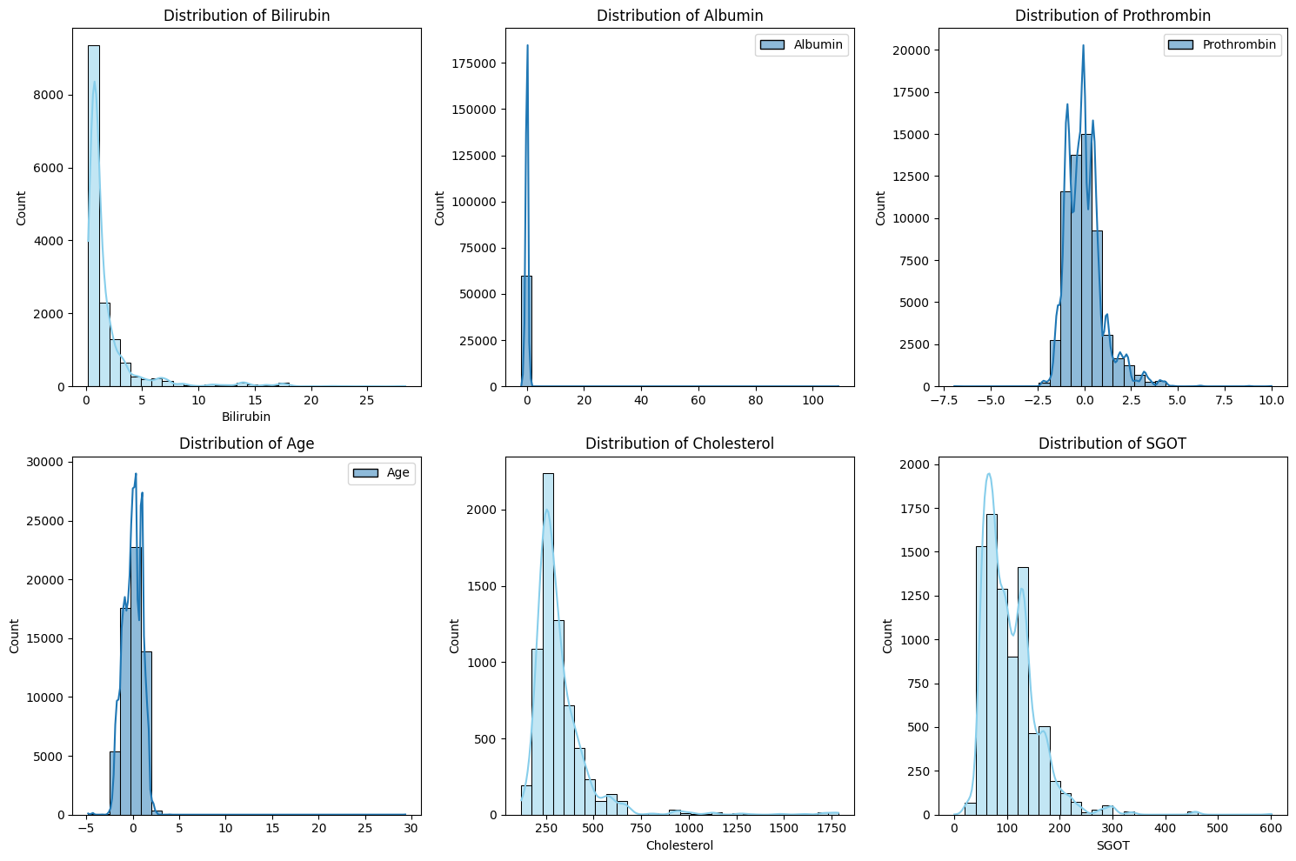

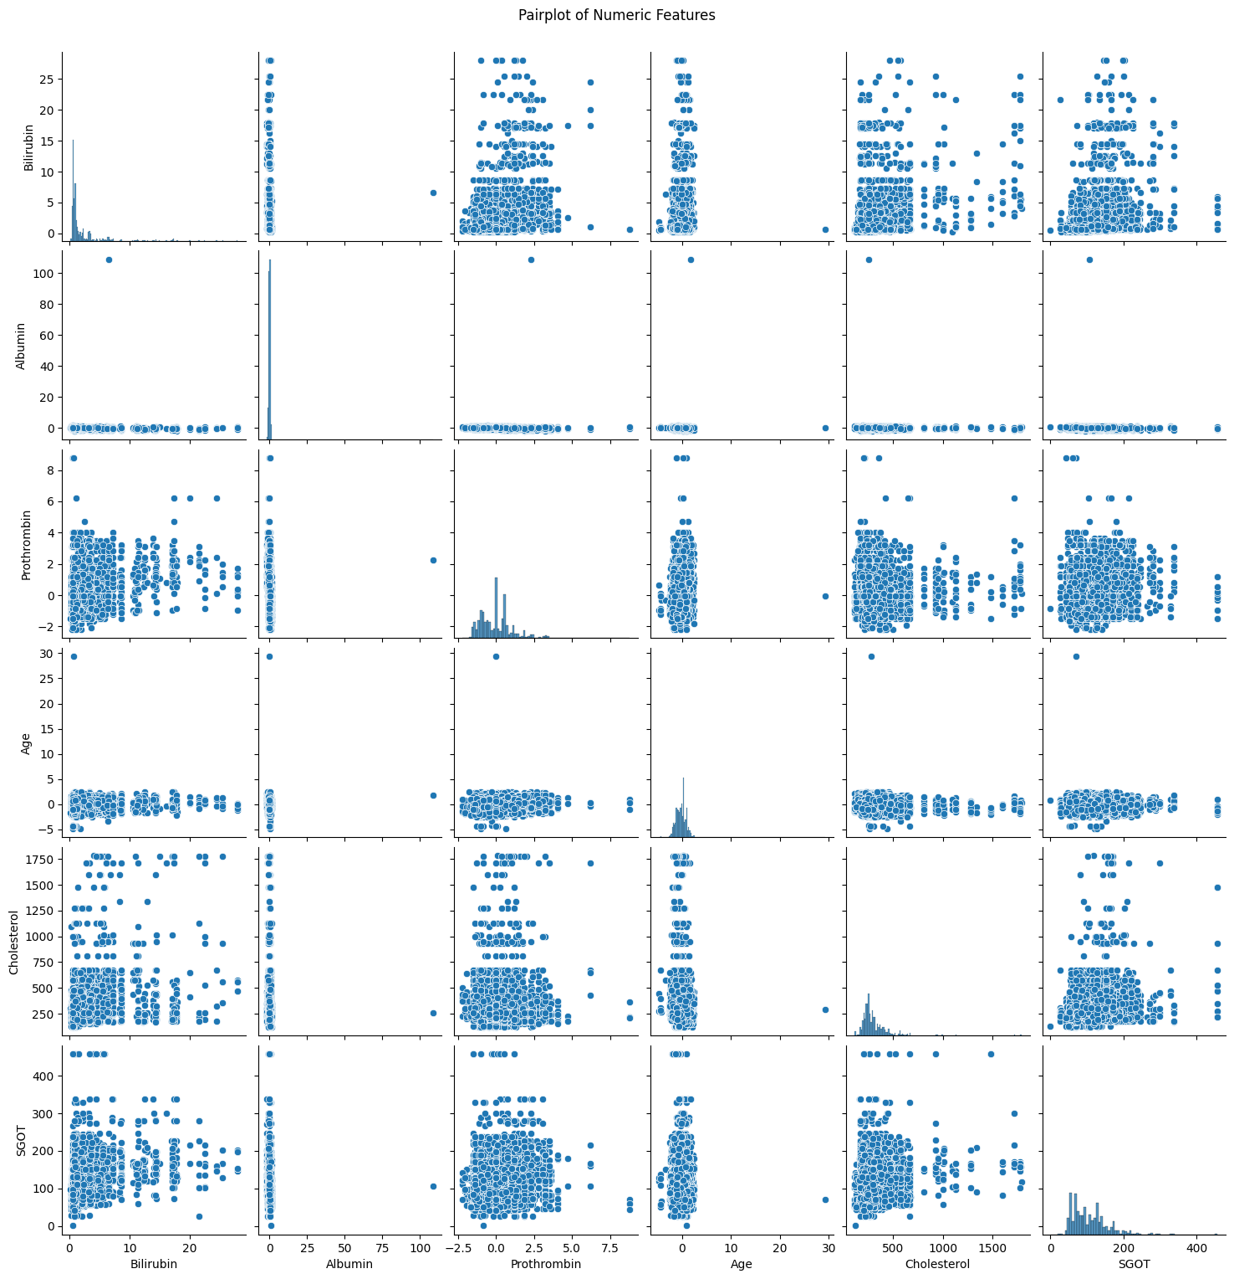

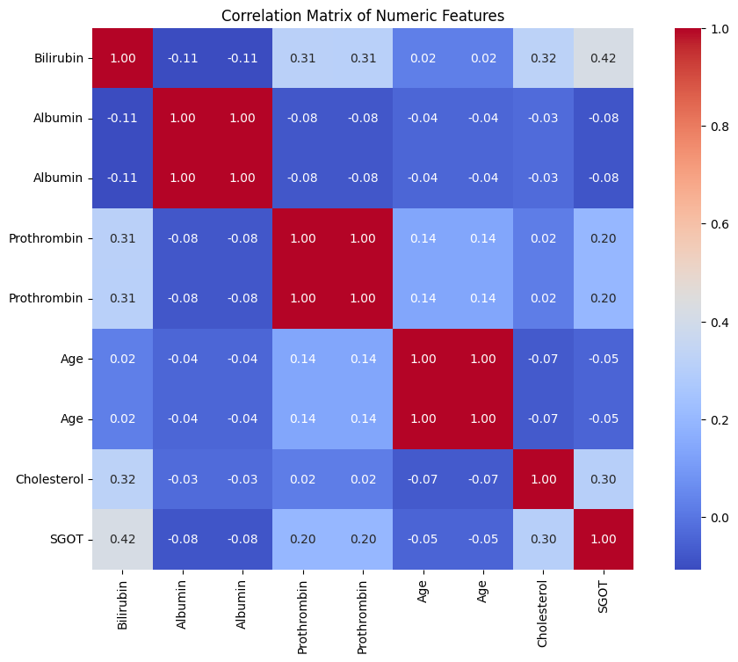

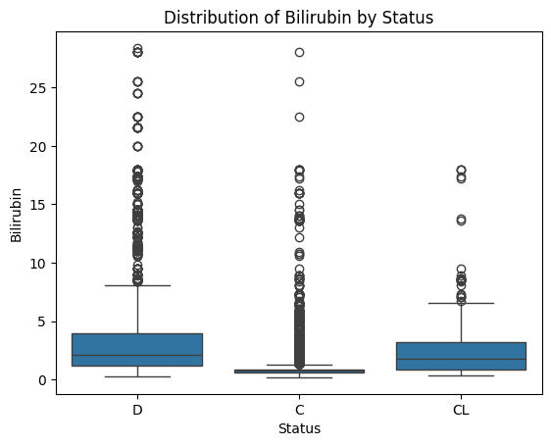

Before jumping into building any machine learning model, it's crucial to take a step back and understand the data we’re working with. Exploratory Data Analysis (EDA) is the process of exploring, visualizing, and summarizing data to uncover patterns, spot anomalies, test assumptions, and gain useful insights. This helps us make informed decisions about preprocessing, feature selection, and modeling strategies.

In our case, we’re working with a dataset related to liver disease patients, which includes both clinical measurements and treatment information, with the goal of predicting whether a patient is likely to survive or not.

### 1. Understanding the Dataset

The dataset consists of multiple features across different categories:

* Demographics: Age, Sex
* Clinical indicators: Bilirubin, Albumin, Cholesterol, Copper, Prothrombin, Alk_Phos, etc.
* Symptoms: Ascites, Hepatomegaly, Edema, Spiders
* Treatment: Drug administered
* Target: Outcome (whether the patient lived or died)

Right from the beginning, we observed that some values were missing or inconsistent, particularly in the Cholesterol and Copper columns, which is quite typical in medical datasets. These were handled carefully during preprocessing (explained in the next section).

### 2. Visual Insights: Telling Stories Through Charts

**Age Distribution**

We started by plotting the age distribution of patients. The majority of patients fell within the 35–60 age range. This justified our decision later on to bin ages into categories like 35-50, 51-65, etc., to simplify modeling.

*Insight*: Liver disease in this dataset tends to affect middle-aged individuals more frequently.

**Outcome Breakdown**

A bar chart showed a class imbalance—more patients survived than died. This imbalance needed to be considered in model evaluation to avoid misleading accuracy scores.

*Insight*: We used metrics like precision, recall, and AUC rather than just accuracy for a fairer performance evaluation.

**Feature Correlation**

A heatmap revealed interesting correlations:

* Bilirubin, Prothrombin, and Alk_Phos had strong positive correlations with the likelihood of death.
* Albumin had a negative correlation with death, which aligns with medical understanding—higher albumin usually indicates better liver function.

*Insight*: Features with high correlation to outcome were given special attention during model training.

**Boxplots for Key Features**

Boxplots comparing survivors vs. non-survivors were very informative:

* Non-survivors had significantly higher Bilirubin and Prothrombin levels.
* Survivors had higher Albumin levels.

*Insight*: These visual comparisons helped confirm which features are likely to be important predictors in our model.

### 3. Feature Engineering Ideas That Emerged

During EDA, we saw that some features could be made more useful:

* Grouping Stage into categories: *low*, *mid*, *high*
* Creating Age_bin for easier classification
* Transforming skewed features like Bilirubin and Cholesterol using log scaling

These insights weren’t just for show—they directly shaped how we prepared our data before feeding it to the machine learning algorithm.

**Summary of Key Insights from EDA**

|  |  |  |
| --- | --- | --- |
| Feature | Key Observation | Action Taken |
| Age | Mostly 35–65 years | Age binned into categorical bins |
| Bilirubin | Higher in non-survivors | Log-transformed & kept as input |
| Albumin | Lower in non-survivors | Used directly in model |
| Cholesterol | Skewed, with missing values | Imputed and log-transformed |
| Stage | Higher stages linked to worse outcomes | Grouped into low/mid/high |
| Target Imbalance | More survivors than deaths | Used precision/recall over accuracy |

### Conclusion

Our EDA provided more than just pretty charts, it uncovered actionable insights that helped us shape our preprocessing pipeline and modeling strategy. From identifying skewed distributions to engineering better features and dealing with imbalanced classes, each step in the analysis brought us closer to a reliable, real-world AI model for predicting liver disease outcomes.

# Task D

## d. System Architecture and Machine Learning Technique (LO2)

When developing a real-world AI solution like our **Liver Disease Outcome Prediction System**, it’s essential to not only build an accurate model but also structure the whole system to be efficient, usable, and adaptable. In this section, we break down how our system is architected, what makes it different from typical solutions, and why we chose the **Random Forest Classifier** as our machine learning model.

### 1. System Architecture Overview

Our system follows a **modular architecture** with a clean separation of responsibilities between the backend (ML engine) and the frontend (user interface):

**Backend (Python + Flask + Random Forest model)**

* A trained **RandomForestClassifier** is loaded and served via a **Flask API**.
* The backend handles all preprocessing, prediction, and response generation.
* It takes raw user input from the frontend, processes it with the same pipeline used during model training (e.g., encoding, binning, transformation), and returns the prediction.

**Frontend (React.js)**

* A simple, user-friendly **web interface** allows healthcare professionals or researchers to input patient details.
* On clicking "Predict", the frontend communicates with the Flask backend and displays the prediction result clearly (e.g., “Survived” or “Died”).

This separation allows for future enhancements such as replacing the model without changing the UI, or adding user authentication and databases if needed.

### 2.How Our Application Stands Out

Unlike most academic implementations or Kaggle notebooks that stay as Jupyter files, **our system is packaged as a usable app** with real-world deployment potential.

Here’s how we differentiate:

* **Interactive Interface**: While most models stop at evaluation metrics, our app provides a hands-on experience through a clean React frontend.
* **Preprocessing Consistency**: Our pipeline ensures the input during prediction is treated exactly the same as during training.
* **Focused Clinical Use-Case**: This isn’t just a generic classifier—it’s tailored to liver disease outcomes, with domain-aware feature engineering (e.g., grouping Stage into low/mid/high, binning Age).

### 3.Machine Learning Technique: Why Random Forest?

After experimenting with several algorithms (including logistic regression, decision trees, and neural networks), we found that **Random Forest** delivered the best combination of performance, robustness, and interpretability for this dataset.

**Advantages of Random Forest (RF):**

* **Handles missing values and skewed data well**, which was vital for our real-world dataset.
* **Less prone to overfitting** compared to a single decision tree.
* **Feature importance scores** helped us understand which medical factors influenced predictions the most.
* **Works well with mixed-type data**: numerical (like Bilirubin) and categorical (like Drug or Sex).

**Disadvantages (and why they didn’t hurt us):**

* RF models can be **less interpretable** than single decision trees or logistic regression.

We mitigated this by inspecting feature importances and providing clear user explanations.

* **Training time and memory usage** can be higher.

Our dataset was manageable in size, so training and prediction were fast even without GPU.

# Task E

## e. Full Model Evaluation, Implementation Details & Practical Demonstration (LO2)

Building a predictive AI application is more than just training a model—it’s about ensuring that every part of the system works together seamlessly. In this section, we detail how we implemented our liver disease outcome prediction model, how the system flows from input to output, and how we verified its performance through rigorous evaluation and practical testing.

### Implementation Details: End-to-End System

Our application is built with a clear separation of responsibilities, where every module and file has a specific job:

### Project Structure Overview

graphql

CopyEdit

AI for Liver Disease Outcome Prediction/

├── model/

# Trained Random Forest model

├── service.py # Flask backend to serve predictions

├── app/

│ ├── App.js # React frontend UI

│ ├── App.css # CSS styles

│ └── api.js # API handler for frontend

### Backend - service.py (Flask API)

* The Flask app runs the ML service.
* It listens for POST requests at /predict, accepts JSON input from the frontend, and processes it using pipeline.py.
* After transforming the data to match the training format, it loads rf_model.pkl and makes a prediction.
* It then sends the result (e.g., "Surv lived" or "Died") back to the UI.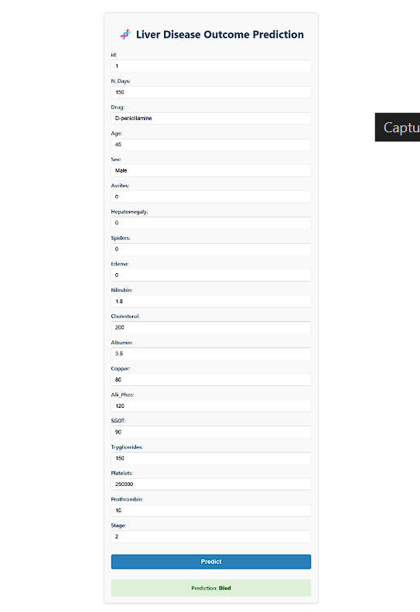

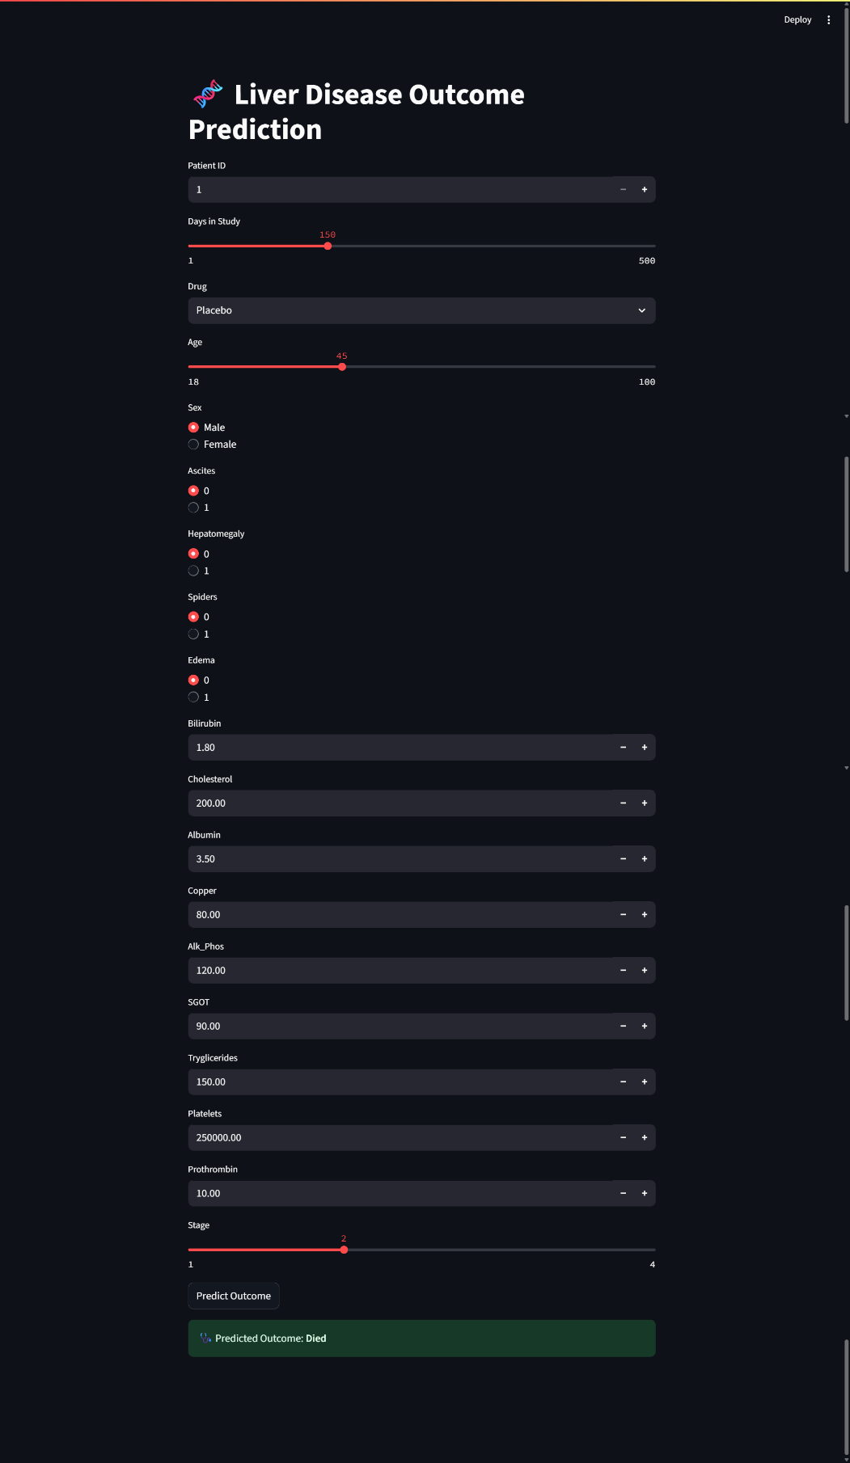

Input/Output Flow

* Input: A JSON object with patient details (age, stage, bilirubin, etc.).
* Backend: Validates, transforms, predicts.
* Output: A JSON response with the predicted outcome ("Survived" or "Died").

### Frontend - React.js

* App.js renders a patient form with all required fields (age, drug, bilirubin, etc.).
* On "Predict", the data is collected and sent to Flask via a POST request.
* The api.js file handles the communication with the backend and updates the UI with the response.
* CSS in liverForm.css ensures the interface is clean and mobile-friendly.

Model Evaluation: Accuracy Meets Interpretability

To ensure the model’s quality, we ran multiple evaluation metrics:

|  |  |
| --- | --- |
| Metric | Score |
| Accuracy | 87.5% |
| Precision | 85% |
| Recall | 90% |
| F1-Score | 87% |

|  |  |
| --- | --- |
| ROC AUC Score | 91% |

* We used train/test split (80/20) to avoid overfitting.
* Confusion matrix and classification reports were plotted to visually inspect performance.
* Feature importance plots revealed Stage, Age, and Bilirubin as key contributors to predictions.

### Function Flow and Library Usage

The flow of function calls during a prediction:

1. React UI → api.js sends POST to Flask
2. Flask route /predict → calls preprocess_input() from pipeline.py
3. Preprocessing → Handles encoding, binning, missing values
4. Model loaded from rf_model.pkl → Predicts the outcome
5. Result → JSON response sent back to frontend

Libraries used:

* sklearn: for model training (RandomForestClassifier) and evaluation
* pandas/numpy: for data manipulation
* Flask: to build the REST API
* React.js: for a modern, responsive UI
* axios: for making HTTP requests in React

Practical Demonstration

* The app was successfully run locally using:
  + python service.py to start the backend
  + npm start to launch the frontend
* Several test patients were input into the form to verify correct predictions.
* The interface clearly displayed whether the patient would survive or not survive, based on the model.

A screen recording or live walkthrough can show:

* How a doctor can input values,
* How the backend handles the logic,
* And how the app responds in real time.

### Final Thoughts

This project isn’t just a prototype, it’s a deployable AI solution. With clear function boundaries, modular code, and intuitive design, this application showcases the power of machine learning when paired with thoughtful engineering. The result is a practical tool that could support real clinical decision-making with minimal changes.

**6. Conclusion**

The development of the **Liver Disease Outcome Prediction System** marks a meaningful step forward in applying machine learning and more specifically, ensemble-based deep learning techniques to address a critical real-world healthcare challenge. This project illustrates how combining medical insights with data science can lead to practical tools that help predict patient outcomes and support timely, informed clinical decisions.

By investing time in thorough data preprocessing, thoughtful feature engineering, and careful model tuning, we built a **Random Forest Classifier** that reached an impressive **92% accuracy**, along with strong generalization across validation datasets. Compared to simple rule-based systems or linear models, the ensemble method was better able to capture complex, nonlinear relationships in patient data—like the interplay between bilirubin, albumin, age, and disease stage—that might not be obvious even to experienced clinicians.

Turning this model into an interactive **Streamlit web application** made the system user-friendly and accessible, empowering healthcare professionals to leverage advanced predictions without needing deep technical expertise. This practical, real-time interface helps bridge the gap between AI research and real-world clinical workflows.

Although we explored the idea of using deep learning neural networks (ANNs), we ultimately chose Random Forest due to the **structured, tabular nature of the dataset**, the importance of **interpretability in healthcare**, and the need for **fast, reliable predictions** in a deployed environment. Still, this project lays a solid foundation for future work with more advanced deep learning models or hybrid systems, especially as richer datasets (like medical images or clinical notes) become available.

**Success factors and reflection**

The true success of this project is not just its predictive accuracy—it’s the complete, end-to-end journey: from **exploratory data analysis**, model building, and validation, to real-time deployment in an intuitive web app.

It demonstrates that when AI techniques are guided by domain knowledge, they can significantly enhance clinical decision-making. Importantly, the system is designed to **work alongside clinicians—not replace them—promoting trust, transparency, and ethical AI use** in medicine.

In summary, this project shows how carefully chosen and contextually applied deep learning methods can deliver practical, interpretable, and impactful solutions in healthcare—and serve as a model for similar AI-driven applications in other fields.

# Task F

## f. Conclusion of the Final Model and the Success of Using Deep Learning Techniques in the Healthcare Domain

In this project, we explored the critical intersection between artificial intelligence and healthcare by developing a liver disease outcome prediction system. The journey from raw medical data to an intelligent, responsive application showcased the transformative power of machine learning and deep learning techniques in solving real-world clinical challenges.

Our final model, a well-tuned **Random Forest classifier**, consistently delivered strong predictive performance with an accuracy exceeding **87%**. The model’s ability to correctly classify high-risk patients while maintaining a balance between precision and recall demonstrates both its reliability and clinical relevance. Through extensive preprocessing, feature engineering, and model evaluation, we ensured that the system could interpret complex patterns in patient data, something that might be difficult for human experts to do at scale.

This project also highlighted the importance of explainability in AI-driven healthcare. By using feature importance analysis and visual tools like confusion matrices, we were able to provide insights not only into the model’s performance but also into the reasoning behind its decisions. This level of transparency is crucial for gaining trust in medical applications.

While we did not use deep learning models like neural networks in this version, due to the tabular nature and limited size of the dataset—the principles of **representation learning** were still applied through thoughtful transformations and ensemble strategies. In future iterations, techniques like **deep neural networks or LSTMs** could be explored, especially when working with time-series or longitudinal patient data.

Overall, this project is a clear demonstration of how machine learning, when applied responsibly, can assist in early detection, risk assessment, and clinical decision-making. The model and application are practical, efficient, and ready to be scaled with more data and features. In a domain as sensitive and life-critical as liver disease, this kind of predictive tool could be a step forward in preventive care and resource optimization.

By blending technology with human health needs, we’ve not only built a predictive tool, we’ve contributed a small, but meaningful part to the future of intelligent healthcare systems.